
Date | 30 September 2026
Team ID | SWTID-2026-1412
Project Name | Import Data using Transform Maps (Spreadsheet)
Team Leader | Hari Jeyalakshmi M
Team Member | Raja Sri M
 | R Pavithra
 | S Muthumari
Maximum Marks | 5 Marks

Project Title:
Import Data using Transform Maps

8. Project Demonstration Phase

A video demonstration was recorded to visually explain the project's execution.

- The video showcases the initial loading of data via the 'Load Data' module.
- It demonstrates the execution of the Transform Map and the subsequent validation of records in the custom table.
- The effectiveness of the 'Coalesce' feature is highlighted by showing a live update of existing data.
- Finally, the video presents the Employee Analytics Dashboards, displaying the generated Pie, Bar, and List reports.
- Demo Video Link: (https://drive.google.com/file/d/1kjhUE3-9lJydieHYJh-3p5sNGuwSJoAb/view?usp=drivesdk)
- GitHub Repository Link: (harijeyalakshmi-m/Import-Data-using-Transform-Maps)

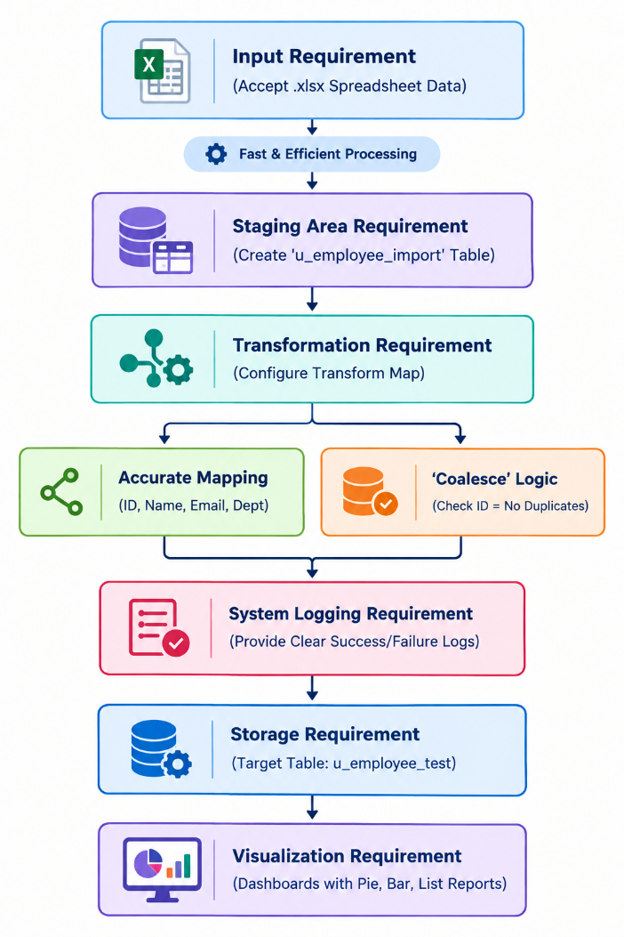

Screenshot

